CRM - System Design & Data Model Specification
Version: 1.0
Date: October 2025
Prepared by: Engineering

1. Architecture Overview
CRM follows a modular service-oriented architecture with a RESTful API layer.
Client: React/Next.js SPA with role-based routing.
API Gateway: Authentication, authorization, rate limiting, validation.
Services: Identity & Access, Lead, Application, Communication, Payment, Form, Reporting.
Data: PostgreSQL (OLTP) using JSONB for flexible fields; Redis for caching & queues; S3-compatible object storage for documents.
Async: Message queue (e.g., SQS/RabbitMQ) for event-driven workflows (lead.created, application.submitted, payment.succeeded, status.changed).
Observability: Centralized logs, metrics, traces (OpenTelemetry).

2. Security & Compliance
OAuth2.1/JWT with short-lived access tokens and refresh tokens.
RBAC at API layer (Admin, Counselor, Student).
PII encryption at rest (column-level) and TLS in transit.
Full audit trail on CUD operations.
Per-channel consent flags with opt-in/opt-out history.

3. Data Model (Entities)
Core Entities:
- User(id, email, name, phone, role_id, status, created_at)
- Role(id, name, permissions)
- Counselor(id, user_id, team, active_leads_count)
- Student(id, user_id, ugc_aicte_flag, dob, address, guardian_contact)
- Lead(id, student_id, source, campaign_id, score, stage, assigned_to, dedupe_key, created_at)
- Program(id, name, session_year, capacity, eligibility)
- ExamScore(id, student_id, exam_type, score, percentile, attempt_date)
- Application(id, lead_id, program_id, status, fee_paid, submitted_at, reviewed_by, decision)
- Payment(id, application_id, amount, currency, pg, pg_ref, status, paid_at)
- Document(id, application_id, type, file_path, verified, verified_by, verified_at)
- CommunicationLog(id, lead_id, channel, template_id, direction, status, sent_at, meta)
- Template(id, channel, name, content, variables, approved)
- Form(id, type, version, schema_json, public_url, active)
- FormField(id, form_id, name, type, rules)
- Submission(id, form_id, student_id, payload_json, created_at)
- AuditLog(id, actor_user_id, entity, entity_id, action, before, after, at)

4. Relationships (Cardinality)
Role 1..* User
User 0..1 Counselor
User 0..1 Student
Student 1..* Lead
Lead 0..* Application
Application 0..* Payment
Application 0..* Document
Lead 0..* CommunicationLog
Template 0..* CommunicationLog
Form 1..* FormField
Form 0..* Submission
Student 0..* ExamScore
Program 1..* Application

5. ER Diagram
The diagram below illustrates key entities and relationships (MVP scope).
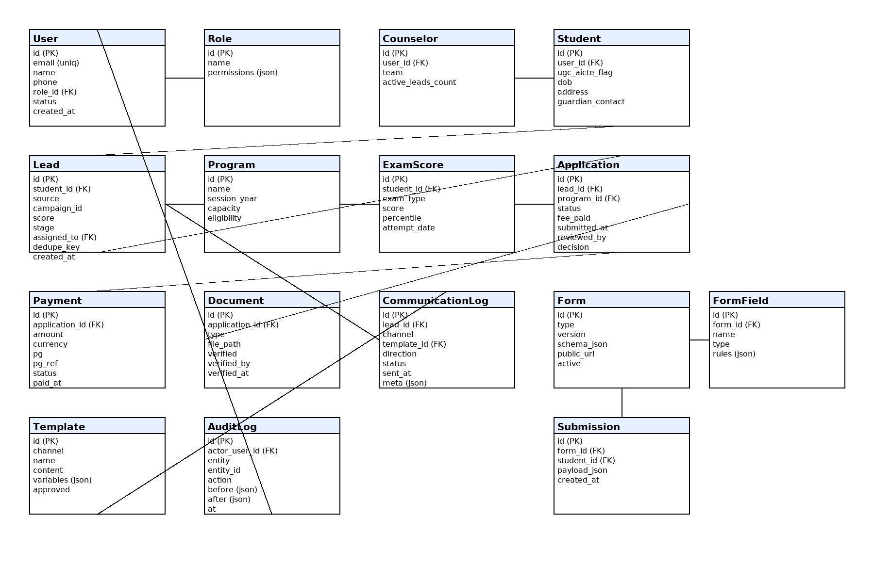

6. API Endpoints (MVP)
Auth & Identity:
- POST /auth/register, POST /auth/login, POST /auth/refresh, POST /auth/logout
- GET /users/me
- GET /users?role=..., PATCH /users/:id
Leads:
- POST /leads (ingest from forms/APIs/CSV)
- GET /leads?stage=&assigned_to=&source=
- GET /leads/:id, PATCH /leads/:id, POST /leads/:id/assign
- POST /leads/:id/notes, GET /leads/:id/communications
Applications:
- POST /applications, GET /applications?status=&program_id=
- GET /applications/:id, PATCH /applications/:id
- POST /applications/:id/documents, GET /applications/:id/documents
Payments:
- POST /payments (create order), POST /payments/webhook
- GET /payments?application_id=, GET /payments/:id
Forms:
- POST /forms, GET /forms, GET /forms/:id, PATCH /forms/:id
- POST /forms/:id/fields, PATCH /forms/:id/fields/:field_id
- POST /forms/:id/submit (public)
Communications:
- POST /communications/send (single/bulk)
- POST /communications/triggers, GET /communications/logs?lead_id=
Reports:
- GET /reports/funnel, GET /reports/counselors, GET /reports/sources

7. Status Lifecycle & Business Rules
Lead.stage: NEW → CONTACTED → INTERESTED → APPLIED → ADMITTED
Application.status: PENDING → UNDER_REVIEW → SHORTLISTED → ADMITTED → REJECTED
Rules:
- Application creation allowed only if Lead.stage ≥ INTERESTED
- Payment required before Application moves to UNDER_REVIEW
- Auto-closure of stale leads after SLA with notification
- Deduplication on (email, phone); merge policy aggregates history

8. Data Retention & Backups
Daily full backups (≥14 days retention) + PITR.
Soft deletes with deleted_at; periodic purge for PII per policy.
Document uploads scanned for malware and versioned.

9. Performance Targets
P95 read ≤ 300 ms; write ≤ 600 ms
Ingestion ≥ 1000 leads/min burst
Notifications ≥ 100 msgs/sec (batched)

10. Environments & DevOps
Envs: dev, staging, prod. IaC via Terraform.
CI/CD with automated tests, SAST/DAST, blue/green deploys.
Feature flags and canary releases for risky changes.

